Forcing .csv to request formatting

Scope:

This is for situations where a csv file opens automatically in excel and results in some information displaying incorrectly due to excel changing the column format to number and so scientific notation.

Example of error as provided by a client:

When I export the assessments using the Assessments with additional commentary report I get connection IDs numbers that are not the right number captured.

The ID on the report shows 100101581940200000 while the correct ID is 100101581940200528

In this scenario, excel automatically formatted the connection id to a number and then a scientific notation as it is an extremely long number.

Example of what scientific notation looks like, with respect to our scenario.

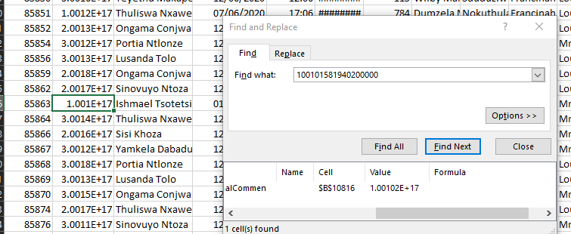

At this point the connection id has now been saved incorrectly and even if you change the formatting of the column it will say as the incorrect number.

To Fix:

Download Notepad++

Download the file as per normal from the app

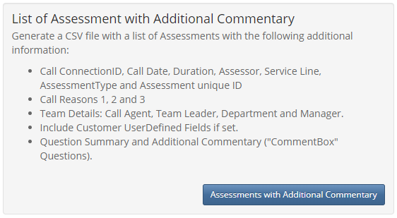

Show in Folder once done

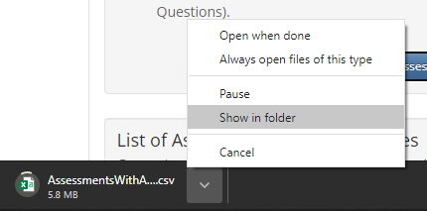



Right click and open file using Notepad++

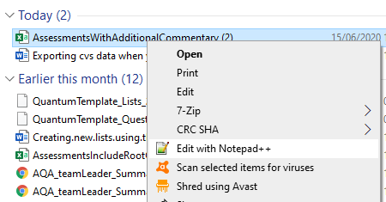

Here our number in our example displays correctly

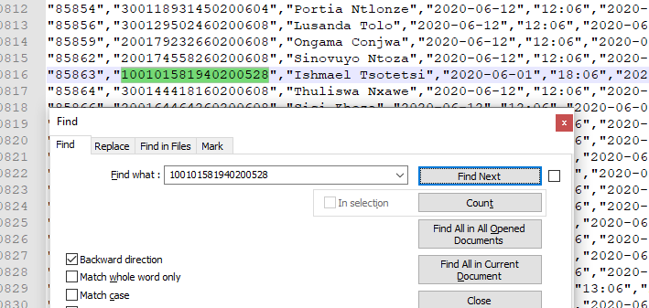

Save this file as a .txt file



Open an excel workbook and browse to this file and open it.

You made get the following message.

Select Yes

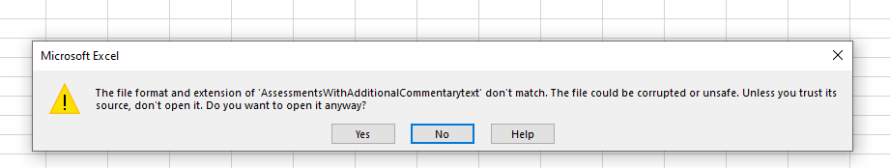

You will then get the Text import Wizard.

Select *Delimited* and *My* *data has headings* before selecting *Next*

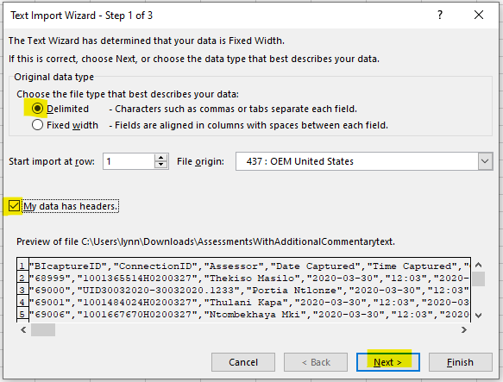

Select *Comma* and *Next*

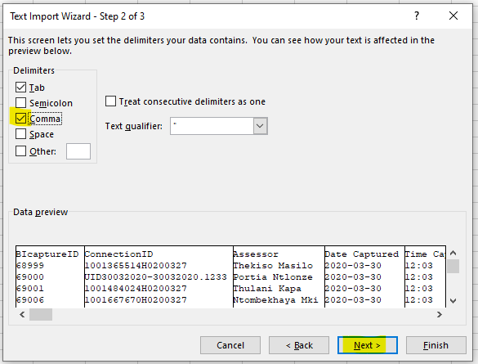

On step 3 of the wizard change the formatting of the ConnectionID column to *Text* and the *Finish*

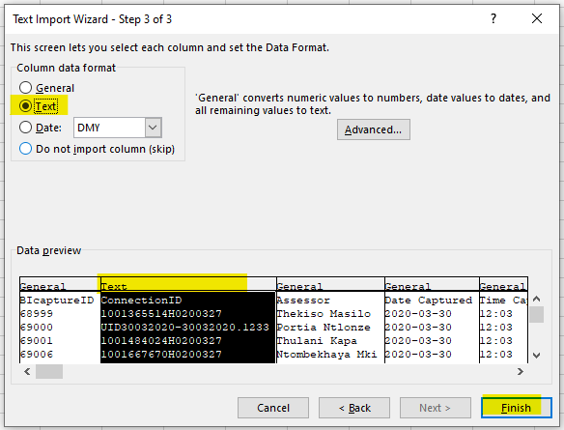

The id will now show correctly in excel

